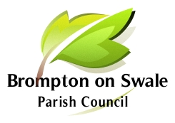

Brompton on Swale Parish Council
Parish Clerk: Martin Reynolds, 31 St Pauls Drive, Brompton on Swale, Richmond DL10 7HQ

Tel: 07849 048581 email: bosparishclerk@hotmail.com

Parish Council meetings take place at the Community Sports Hall,
Honey Pot Road, Brompton-on-Swale, DL10 7HT.

Meeting Dates for 2024

18 January 7.00pm

14 March 7.00 pm

11 April 7.00 pm

16 May – Annual Parish Meeting and AGM 7.00 pm

18 July 7.00 pm

5 September 7.00 pm

24 October 7.00 pm

5 December 7.00pm

